**MUSICAL FREQUENCY NOTE DETECTION**

**Manish Godbole1, Kaustubh Joshi1, Aditya Kadu1, R.A.Kulkarni2**

1 Student, Third Year Computer Engineering, Pune Institute of Computer Technology

2 Assistant Professor, Computer Engineering, Pune Institute of Computer Technology

***Abstract*-** Accurate and precise identification of musical notes is essential for activities such as automatic tuning, transcription, and instrument recognition. The suggested detector uses sophisticated signal processing methods to examine audio input and ascertain the fundamental frequency (pitch) of the dominant musical note being played.

The system employs a blend of time-domain and frequency-domain analysis to extract pertinent features from the input audio signal. These features are then input into a classifier based on machine learning that identifies the nearest musical note corresponding to the detected frequency. To guarantee robustness and precision, the system has been trained on an extensive dataset encompassing a broad spectrum of musical instruments and playing styles. Our research introduces the design, execution, and assessment of a unique musical frequency note detector aimed at instrumental applications in diverse musical contexts.

***Keywords****:* Audio input, fundamental frequency, pitch, time-domain, frequency-domain,frequency note detector.

**I. INTRODUCTION**

Music, a global medium that bridges geographical and cultural divides, has consistently been a focus of intrigue and research. The capacity to dissect and comprehend music’s subtleties, such as identifying individual musical notes within a piece, has extensive implications in areas from music theory and pedagogy to audio processing and digital signal examination. This research article ventures into the sphere of musical frequency note detection, a vital field of study in music technology. By investigating the principles and methodologies underlying this process, we aspire to illuminate the fundamental mechanics of musical notes, their frequencies, and how cutting-edge technology can aid their accurate identification. In doing so, we anticipate opening up new pathways for creativity, education, and innovation in the music domain..

**II. LITERATURE REVIEW**

**“Jay K. Patela, E.S.Gopia [1]”**

A song contains basically two things, vocal and background music. Where the characteristics of the voice depend on the singer and in case of background music, it involves mixture of different musical instruments like piano, guitar, drum, etc. To extract the characteristic of a song becomes more important for various objectives like learning, teaching, composing. The experiment is done with the several piano songs where the notes are already known, and identified notes are compared with original notes until the detection rate goes higher. And then the experiment is done with piano songs with unknown notes with the proposed algorithm.

**“Victor Lazzarini and Joseph Timoney[2]”**

This article provides a review of some of the most commonly used techniques for real-time onset detection. It suggest ways to improve these techniques by incorporating linear prediction as well as presenting a novel algorithm for real-time onset detection using sinusoidal modelling. As well as provides comprehensive results for both the detection accuracy and the computational performance of all of the described techniques, evaluated using Modal

**“Allabakash Isak Tamboli* and Rajendra D. Kokate[3]”**

In this research, the authors developed a musical note recognition method based on an optimization-based neural network (OBNN) within a classification framework. The study involved an extensive review of existing approaches for musical note recognition. The use of OBNN for recognizing musical notes was explored. The document comprehensively analyzes recent investigations related to musical note recognition, summarizing their findings and classifications, with the aim of advancing the effectiveness of this recognition process through diverse methodologies.

**" Smith, Julius O. [4]”**

The paper gives seminal work in the field of digital audio processing. This paper delves into the principles and methodologies of physical modeling, which simulates the behavior of real-world musical instruments and sound effects in the digital domain. It explores the mathematical and computational foundations of physical modeling, allowing for the creation of highly realistic virtual instruments and audio effects. By emphasizing the accurate emulation of physical interactions and acoustic phenomena, Smith's research paper has been pivotal in advancing the quality and authenticity of digital music synthesis and audio processing. It remains a foundational reference for researchers and engineers in the field.

**"B. Li, T. Virtanen, J. Schlüter, S. -Y. Chang and T. Sainath, [5]”**

The paper gives comprehensive overview of the application of deep learning techniques in the field of audio signal processing. It explores the use of neural networks and deep learning architectures for tasks such as speech recognition, music analysis, and sound synthesis. The paper discusses various deep learning models and their effectiveness in handling complex audio data. It serves as a valuable resource for researchers and practitioners interested in leveraging deep learning for advanced audio processing applications.

**" S. A. Shedied, M. E. Gadalah and H. F. VanLundingham [6]”**

The paper presents Critical problem of accurately estimating pitch in speech signals contaminated by noise. The authors propose a novel pitch estimation method tailored for noisy conditions, focusing on the challenging scenario of adverse environmental or recording conditions. Their approach combines adaptive filtering and signal processing techniques to enhance the accuracy and robustness of pitch estimation in the presence of noise. This paper presents an essential contribution to speech signal processing, particularly in contexts where noise interference poses a significant challenge, making it valuable for applications like speech recognition and enhancement.

**"S. Wang, A. Politis, A. Mesaros and T. Virtanen [7]”**

The paper senses self-supervised learning approach that leverages audio-visual data with spatial alignment to enhance audio representation learning. The proposed method combines visual information and audio signals to train deep neural networks without explicit annotations. By exploiting spatial alignment cues, the model learns robust and informative representations, which have applications in areas such as speech and sound analysis, offering potential benefits for improving the accuracy of audio-based tasks using multi-modal data

**III. METHODOLOGY**

1. **Audio Loading**: Audio Import: The code initiates by importing an audio file (‘test.mp3’) utilizing the librosa.load function, which results in the raw audio waveform and its sampling rate (SR). This action readies the data for further examination.

2. **Waveform Visualization**: It continues with the display of the audio waveform using Matplotlib. This display illustrates the amplitude of the audio signal as it progresses over time, offering a visual comprehension of the audio’s attributes.

3. **Amplitude Envelope**: To scrutinize the signal’s fluctuations, two functions, amp_env and fancy_amp, are employed to calculate the amplitude envelope. The amplitude envelope seizes the peak amplitude within designated frame sizes, a vital feature for a variety of audio processing tasks.

4. **Time and Frame Calculation**: The code begins by determining the time and frame indices for the amplitude envelope using the librosa.frames_to_time function. This step aligns the envelope with time for subsequent visualization.

5. **Visualizing the Envelope**: The code then generates another Matplotlib plot, which displays the audio waveform and overlays the amplitude envelope in red. This visualization aids in understanding the amplitude’s temporal variations.

6. **Short-Time Fourier Transform (STFT)**: To delve into the audio's time-frequency characteristics, the code computes the STFT using `librosa.stft`. The STFT provides a detailed representation of the audio signal in the time and frequency domains.

7. **Pitch Detection**: For pitch analysis, the code uses the `librosa.piptrack` function to identify pitch frequencies in each frame. This process is achieved by tracking the peaks in the magnitude of the STFT.

8. **Note Mapping**: A dictionary, `note_mapping`, is defined to map detected frequencies to their corresponding musical note names, allowing for easier interpretation of the pitch information.

9. **Average Pitch Calculation**: The code calculates the average pitch within specific frame intervals to provide a more generalized view of the audio's pitch characteristics. It calculates the mean pitch, ignoring any NaN values in the pitch data.

10. **Displaying Results**: Finally, the code prints and displays the average frequency and corresponding musical notes for each set of frames at specified intervals.

**IV. IMPLEMENTATION**

We integrate signal processing, visualization, and feature extraction techniques to analyze audio data, highlighting attributes such as amplitude variations and pitch characteristics in a structured and visually informative manner.

The methodology primarily relies on traditional audio analysis techniques and visualization, rather than machine learning models or classifiers.

**V. RESULT**

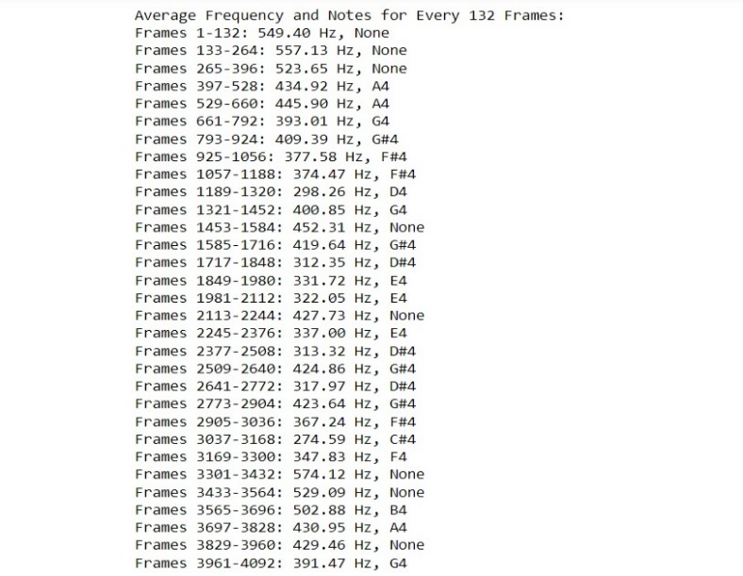

**VI ARCHITECTURE DIAGRAM**

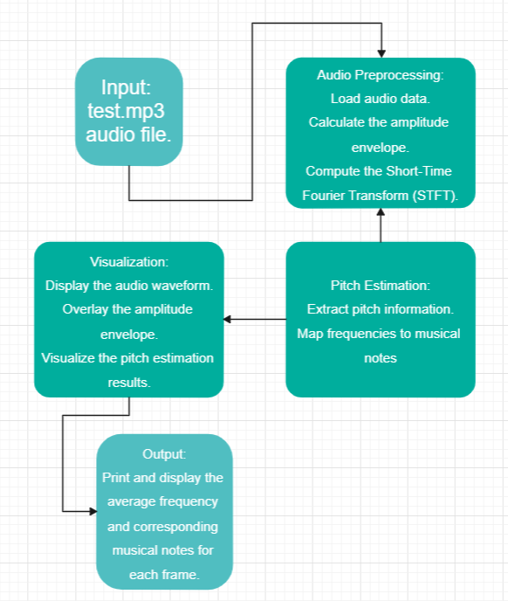

**VII. CONCLUSION**

The primary objective of this study is to comprehend the detection of musical frequency notes, highlighting the immense possibilities for application development and its significant influence on music and technology. The necessity for precise note detection spans various areas, including music education, transcription, and audio processing. Accurate note identification provides essential tools for musicians and learners, enhancing music teaching and learning, and allowing musicians to perfect their performances and compositions. Moreover, our research has demonstrated how advancements in technology, such as digital signal processing and machine learning, have streamlined and democratized automated note detection, paving the way for the creation of software tools and applications that assist musicians of all skill levels. In addition, our research emphasizes the critical need for meticulous investigation in this field, underscoring the importance of extensive and diverse datasets, sturdy algorithms, and the ongoing refinement of techniques to boost the precision and dependability of note detection systems. In essence, the goal of musical frequency note detection extends beyond the technical sphere, fusing creativity and education with technology. This harmonious integration of music and technology opens up new avenues for articulating artistic work with learning. As we persist in refining and innovating, we envision a future where music becomes more accessible, lucid, simple, and enriched for everyone. This research uncovers the immense potential that awaits in the domain of musical note detection.

**REFERENCES**

1. Smith, Julius O. "Physical Audio Signal Processing for Virtual Musical Instruments and Audio Effects." W3K Publishing, 2010.
2. H. Purwins, B. Li, T. Virtanen, J. Schlüter, S. -Y. Chang and T. Sainath, "Deep Learning for Audio Signal Processing," in IEEE Journal of Selected Topics in Signal Processing, vol. 13, no. 2, pp. 206-219, May 2019, doi: 10.1109/JSTSP.2019.2908700.
3. S. A. Shedied, M. E. Gadalah and H. F. VanLundingham, "Pitch estimator for noisy speech signals," Smc 2000 conference proceedings. 2000 ieee international conference on systems, man and cybernetics. 'cybernetics evolving to systems, humans, organizations, and their complex interactions' (cat. no.0, Nashville, TN, USA, 2000, pp. 97-100 vol.1, doi: 10.1109/ICSMC.2000.884971.
4. S. Wang, A. Politis, A. Mesaros and T. Virtanen, "Self-Supervised Learning of Audio Representations From Audio-Visual Data Using Spatial Alignment," in IEEE Journal of Selected Topics in Signal Processing, vol. 16, no. 6, pp. 1467-1479, Oct. 2022, doi: 10.1109/JSTSP.2022.3180592.
5. Hendrik Purwins , Bo Li , Tuomas Virtanen , Jan Schluter ¨ , Shuo-Yiin Chang, and Tara Sainath, “Deep Learning for Audio Signal Processing” in IEEE Journal of Selected Topics in Signal Processing, vol. 13, no. 2, May 2019.
6. Jay K. Patela, E.S.Gopia. “Musical Notes Identification using Digital Signal Processing”. 3rd International Conference on Recent Trends in Computing 2015 (ICRTC-2015)
7. John Glover*, Victor Lazzarini and Joseph Timoney. “Real-time detection of musical onsets with linear prediction and sinusoidal modeling”. EURASIP Journal on Advances in Signal Processing.
8. Allabakash Isak Tamboli* and Rajendra D. Kokate. “An Effective Optimization-Based Neural Network for Musical Note Recognition”.